NYEFC EDWARD PLACKE SPORTSMANSHIP SCHOLARSHIP

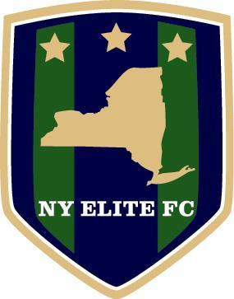
This scholarship is presented in honor and recognition of Edward "Ed" Placke for his years of service to the sport of youth soccer in the Capital District. Edward Placke dedicated many years establishing soccer programs for children to play in a fun, competitive and enriching environment. Many young soccer players have grown and developed into fine young adults and athletes through programs Ed spearheaded. He recently retired from soccer in the Capital District and New York Elite FC would like to thank him for what he has established and for what will continue to carry on for years to come. In the spirit aof New York Elite FC Soccer, the club will award four $250 college scholarships to two boys and two girls that best exemplify the spirit of true sportsmanship in the sport of soccer. Applicants must be graduating high school seniors that are attending college in the fall and are currently playing for NYEFC.

Application Instructions

- Please fill in the information requested below.
- Email completed applications to Blair Downie at brdownie62@gmail.com or mail to Blair Downie, 819 4th Ave, Troy, NY 12182
- Applications Must Be Received by June 4, 2021

Applicant Information

Name
Address
Phone
Email
Number of Years playing Club Soccer with NYEFC

Academic Information

Name of High School
Grade Point Average
Class Rank/# in Class
Graduation date (month/year)
Academic Awards/Honors
Name of post-secondary school you plan to attend or list of those you have applied to
Intended Major

Extracurricular Activities
Please describe the extracurricular activities in which you have participated during the past four years. Indicate school year(s) (grade level) for each activity, note special awards, honors and offices held. Insert additional rows in table if necessary.

School Year | Activity | Awards, Honors, Offices Held

Community Service
Please describe the community service/volunteer work in which you have participated without pay during the past four years. Indicate school year(s) (grade level) for each activity, approximate number of hours per week, and number of weeks per year. Insert additional rows in table if necessary.

Organization | Community Service Activity | School Year | # hours per week | # weeks per year

Work Experience
Please describe your work experience during the past four years. Indicate school year(s) (grade level) for each job, approximate number of hours worked each week, and number of weeks worked each year. Insert additional rows in table if necessary.

Employer | Position | School Year | # hours per week | # weeks per year

